Name - Prerna Choudhary

Sap id – 500083151

Roll no. – R214220864

**Experiment – 1**

AIM: Installing Vagrant & Creating basic vagrant box using Virtual Box virtualization.

1. Download and Install Oracle Virtual Box 5.x and Vagrant 2.2.7.

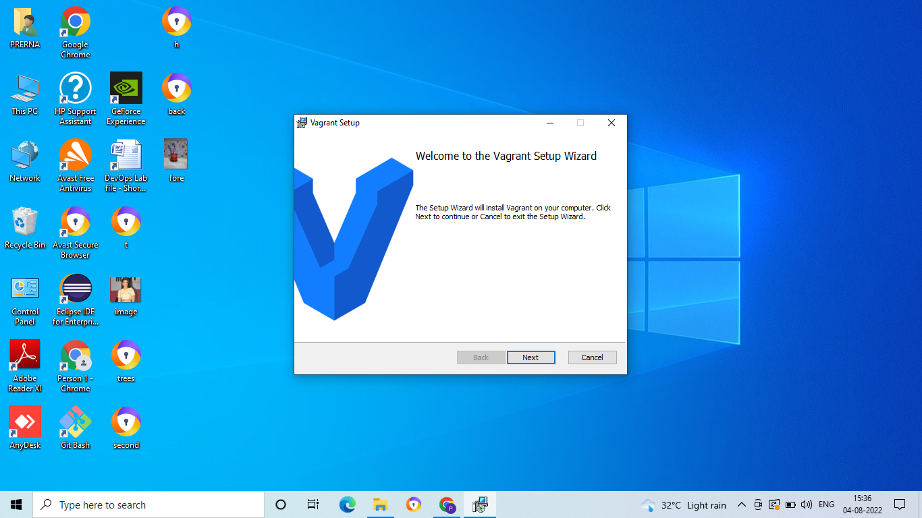

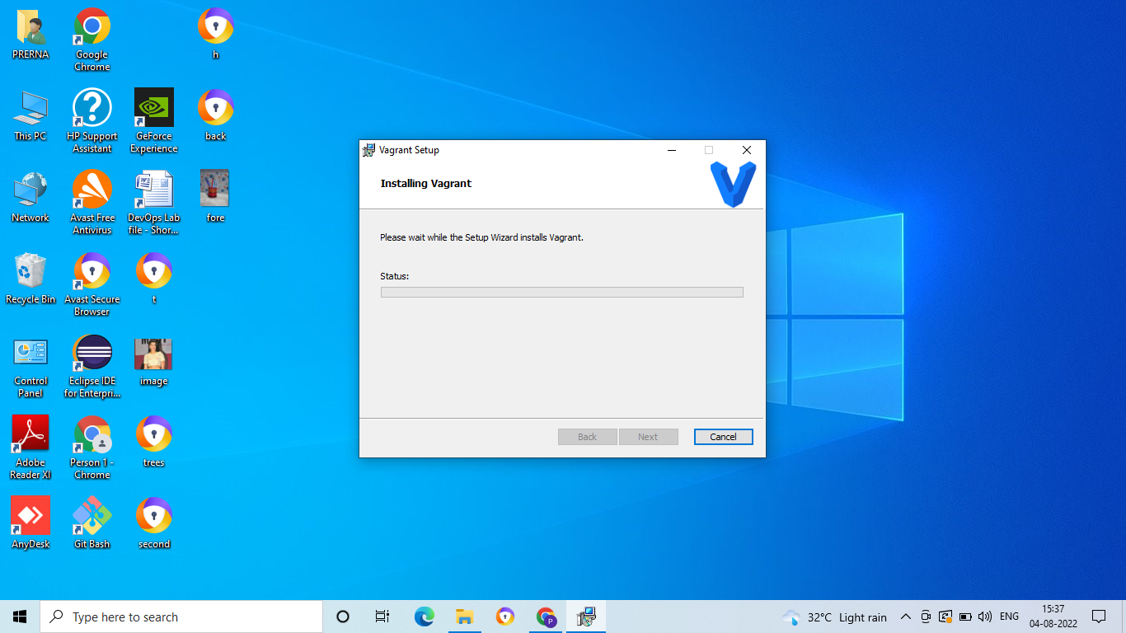

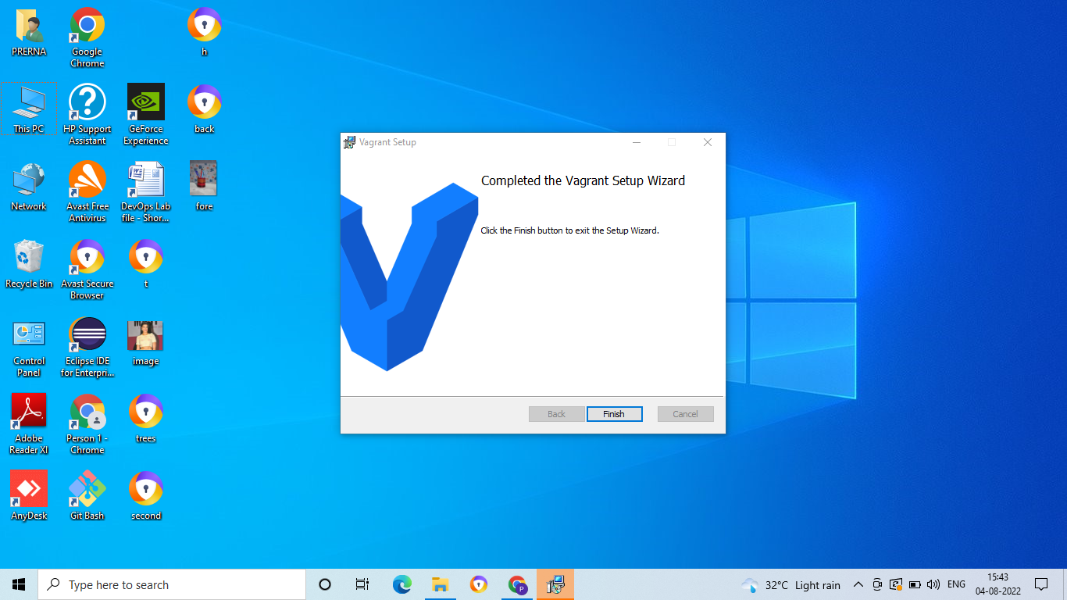

2. Check working of Vagrant using vagrant --version command.

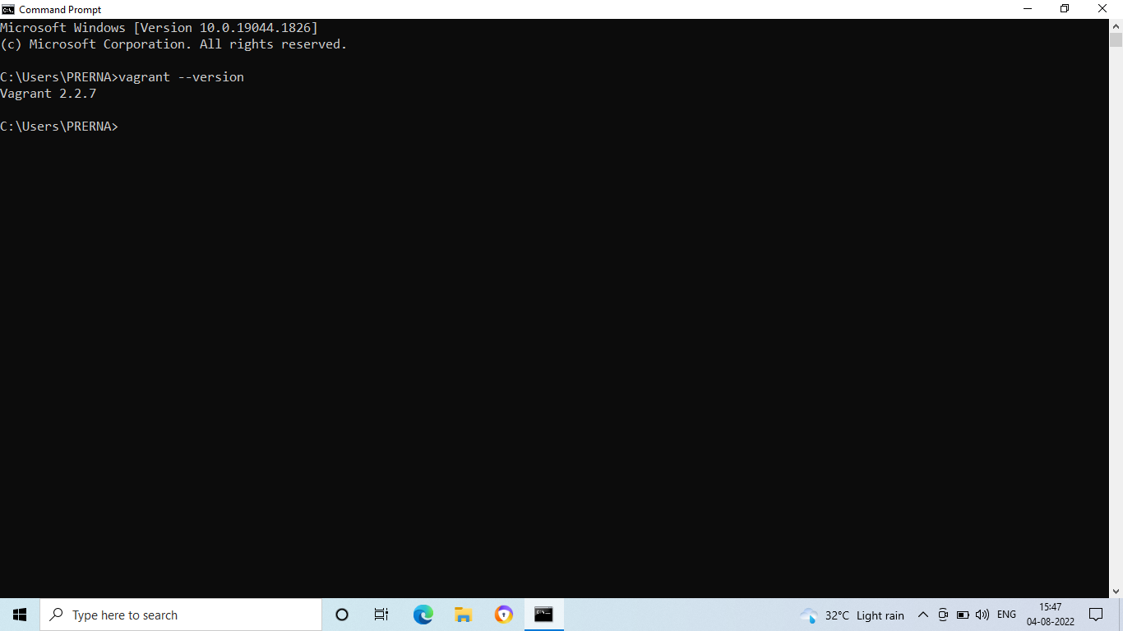

1. Create a new directory using CMD.

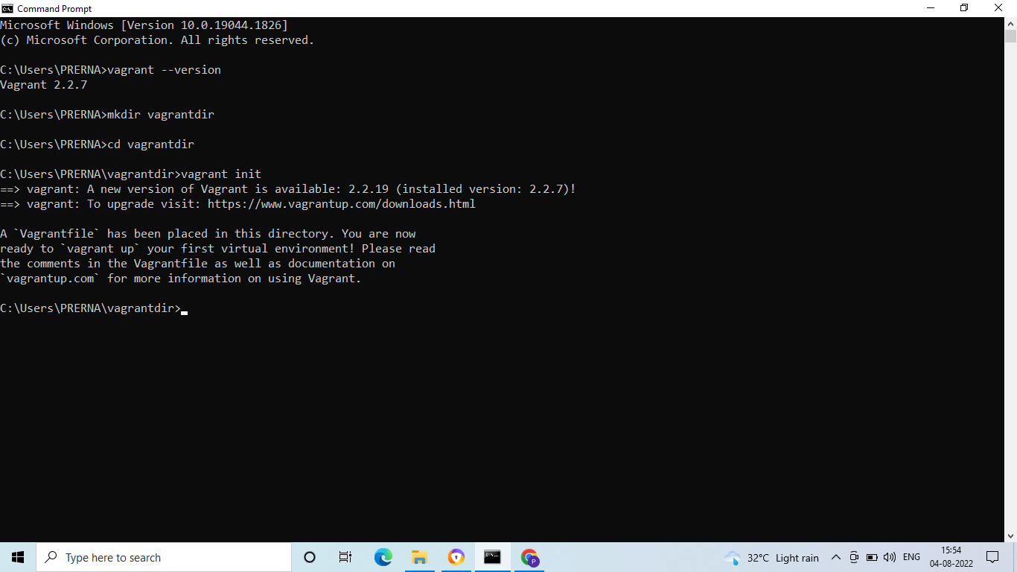

1. Run vagrant init command

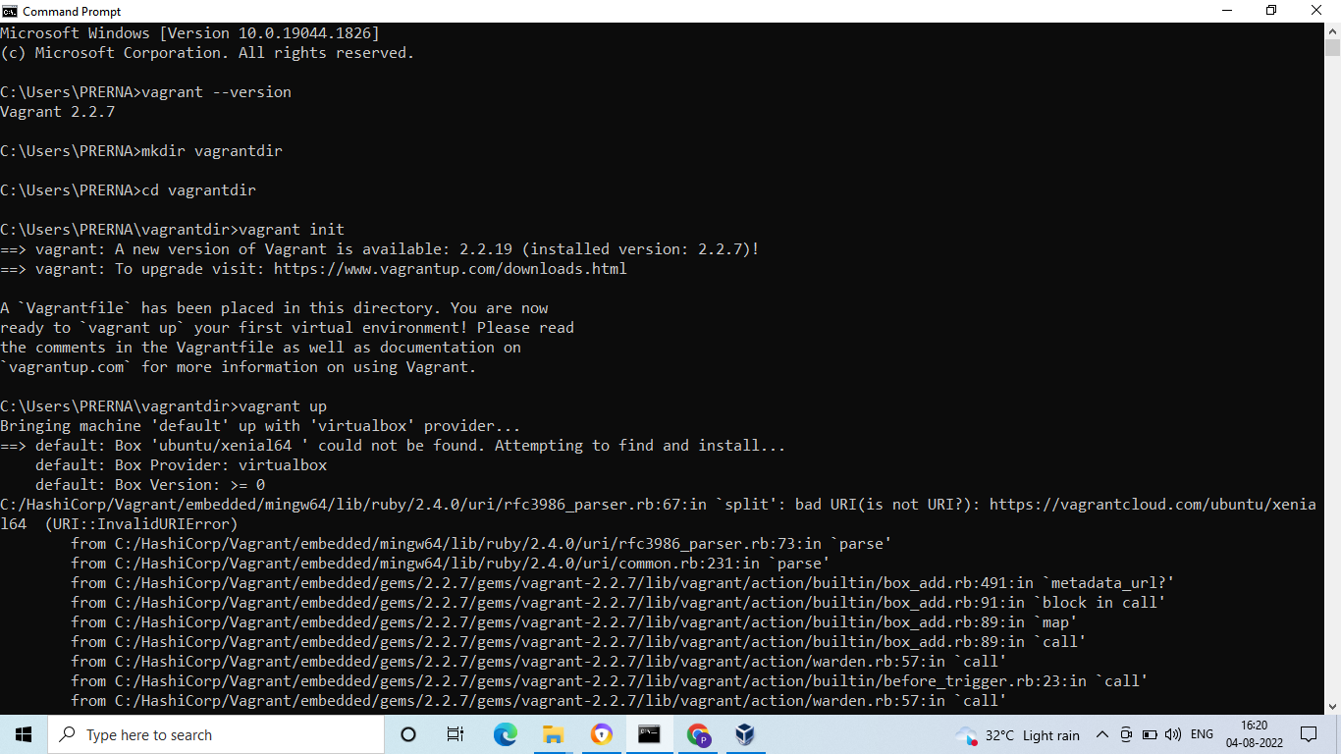

1. Edit vagrantfile and add ubuntu/xenial64 in box tag

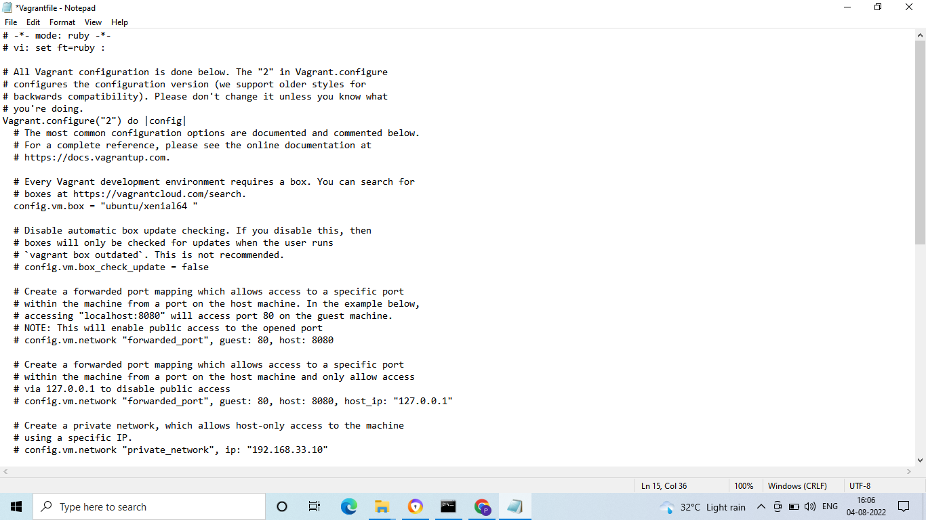

1. Run vagrant up command

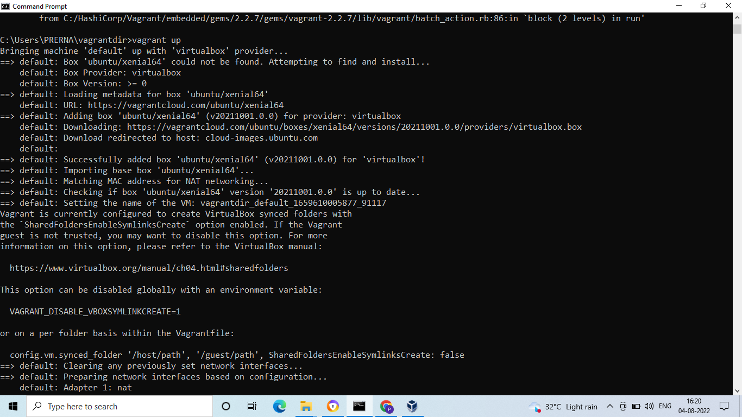

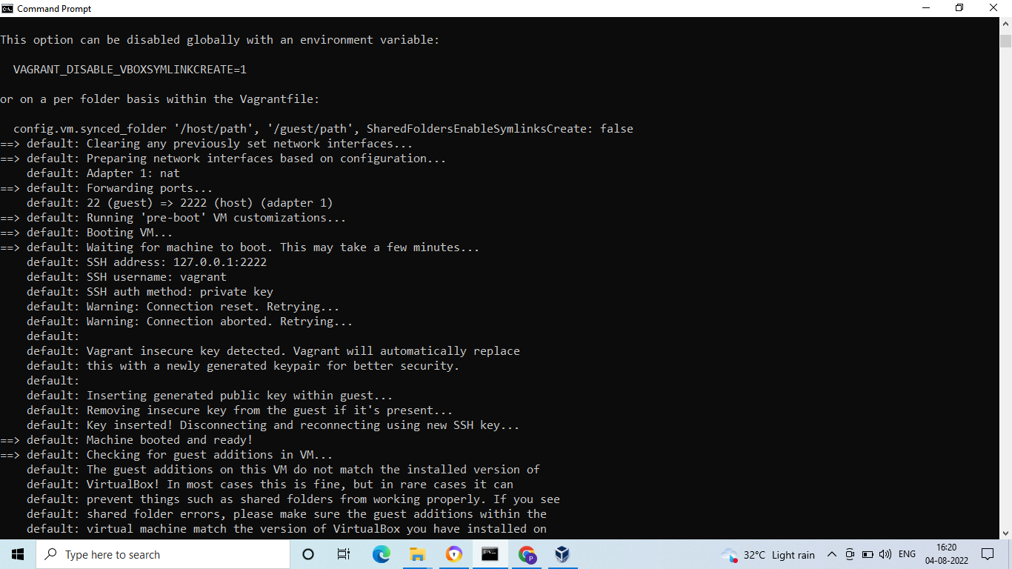

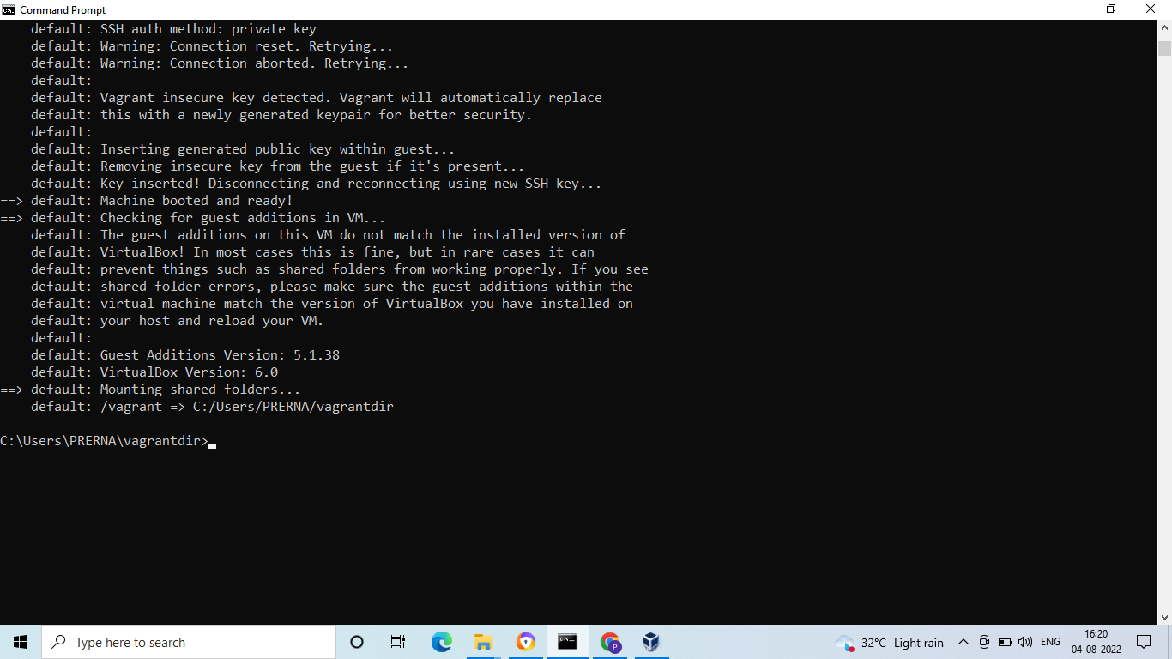

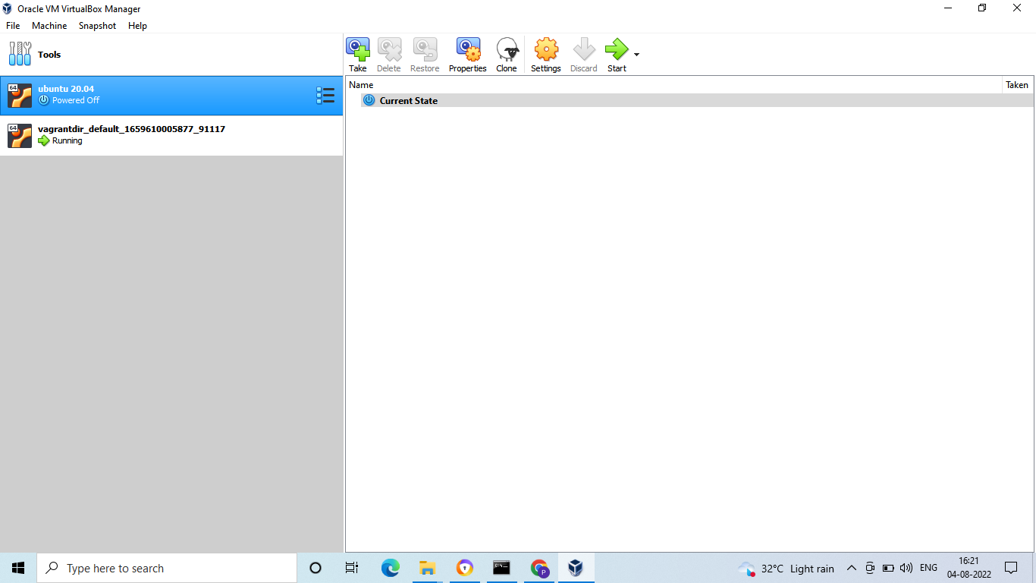

1. Run vagrant SSH command

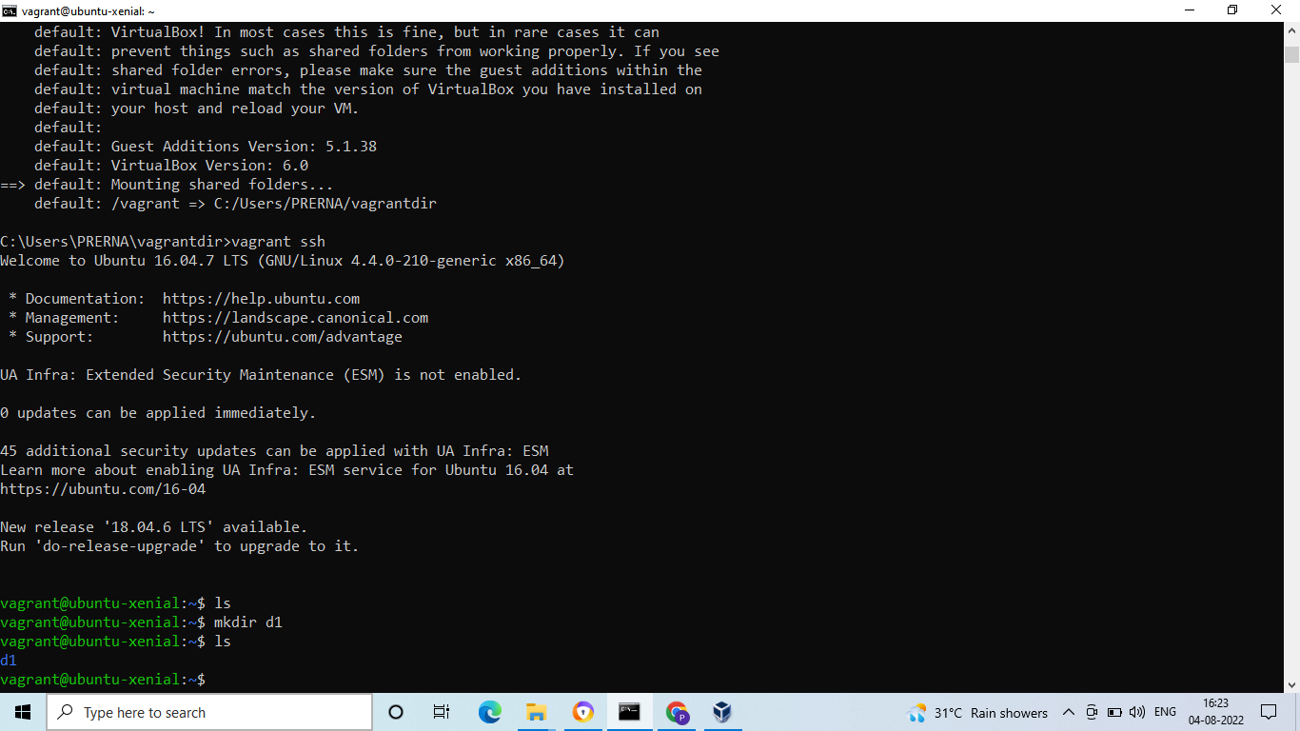

1. Run Vagrant Halt to stop VM

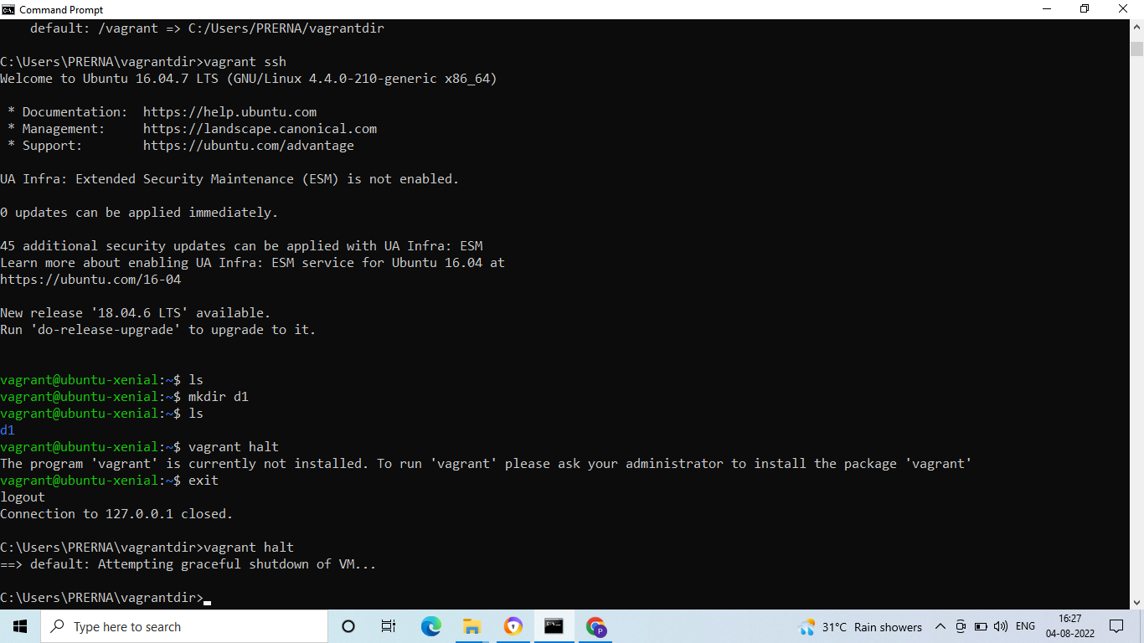

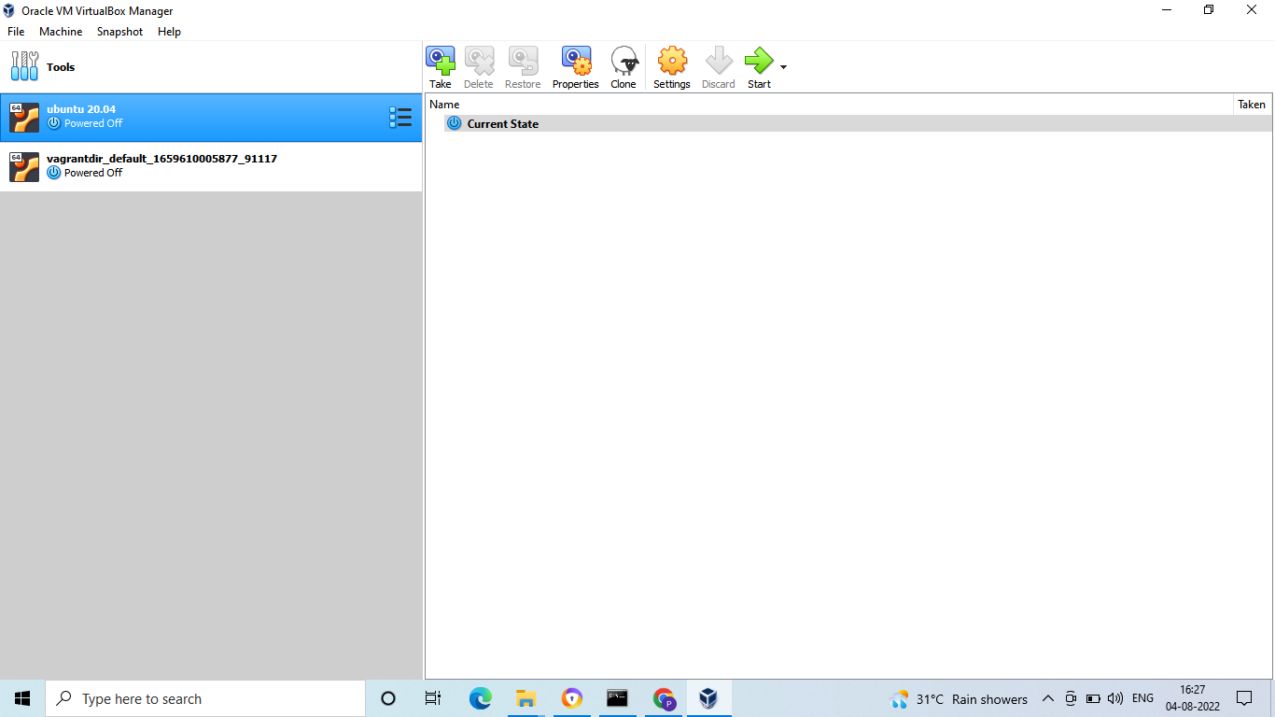

1. Run Vagrant Destroy to delete VM

